CHRISTMAS IN JULY RAFFLES 2025
AINSLIE GROUP
RAFFLE PROMOTION

Offer:
Both venues, Ainslie Football & Social Club and Gungahlin Lakes Golf & Community Club, will be giving away an array of Christmas in July Raffle products to replace the existing weekly raffles.

The offering will encompass a merged regular raffle offering with inclusions of Christmas hams and turkey rolls.

This will take place of the Friday night (Gungahlin) and Wednesday night (Ainslie) for the duration of July.

Tickets will go on sale from 5:30pm with draws commencing at 7:00pm on raffle days.

Key Dates:
Gungahlin – 4th, 11th, 18th, 25th July

Ainslie – 2nd, 9th, 16th, 23rd, 30th July

Prizes:

Gungahlin
10 x hams, 5 x turkeys, 10 x meat trays, beer, wine &
Vouchers:
1 x $100 Ainslie Group Voucher

Ainslie
6 x hams, 4 x turkeys, 2 x meat trays, 4 x cases of beer, 2 x wine packs

Vouchers:
1 x Seafood Dining Voucher ($180+ value)
1 x Pizza Bundle voucher (2 x pizzas, 1 x garlic bread + bottle of wine (up to $46) or jug of tapped beer
1 x Sunday Roast for 2 voucher (+ 3 free kids meals (max), bottle of wine (up to $46) or jug of any tapped beer).

Collateral:

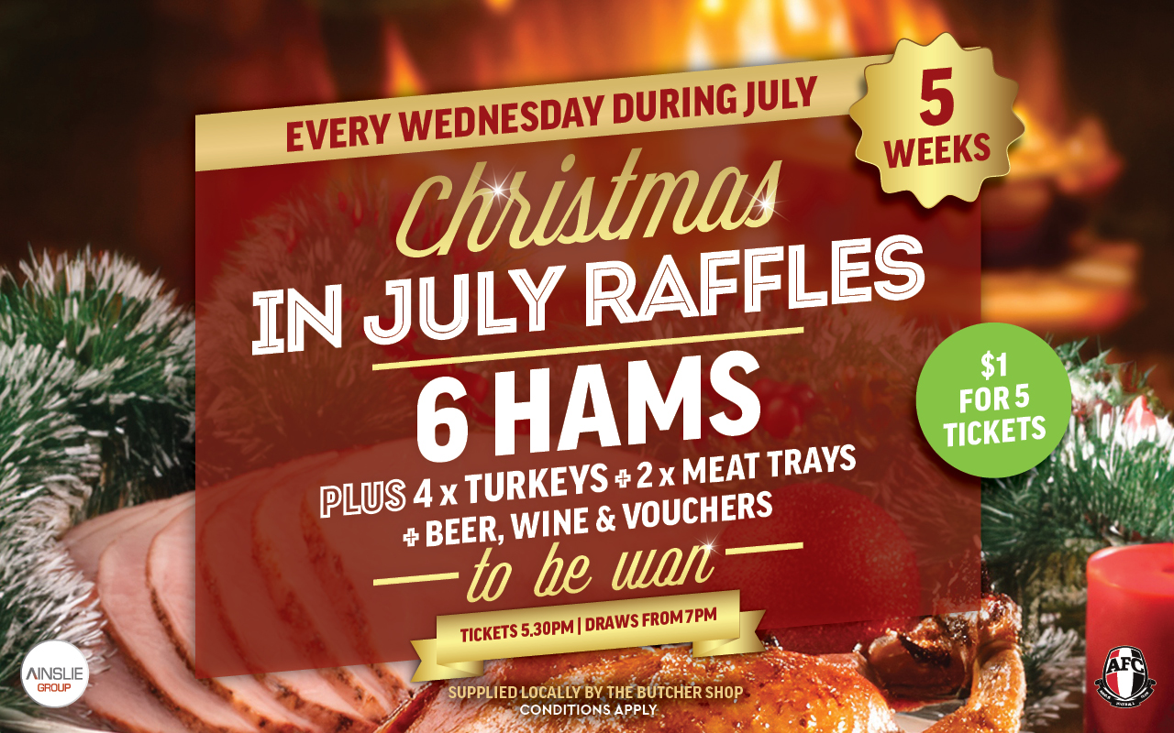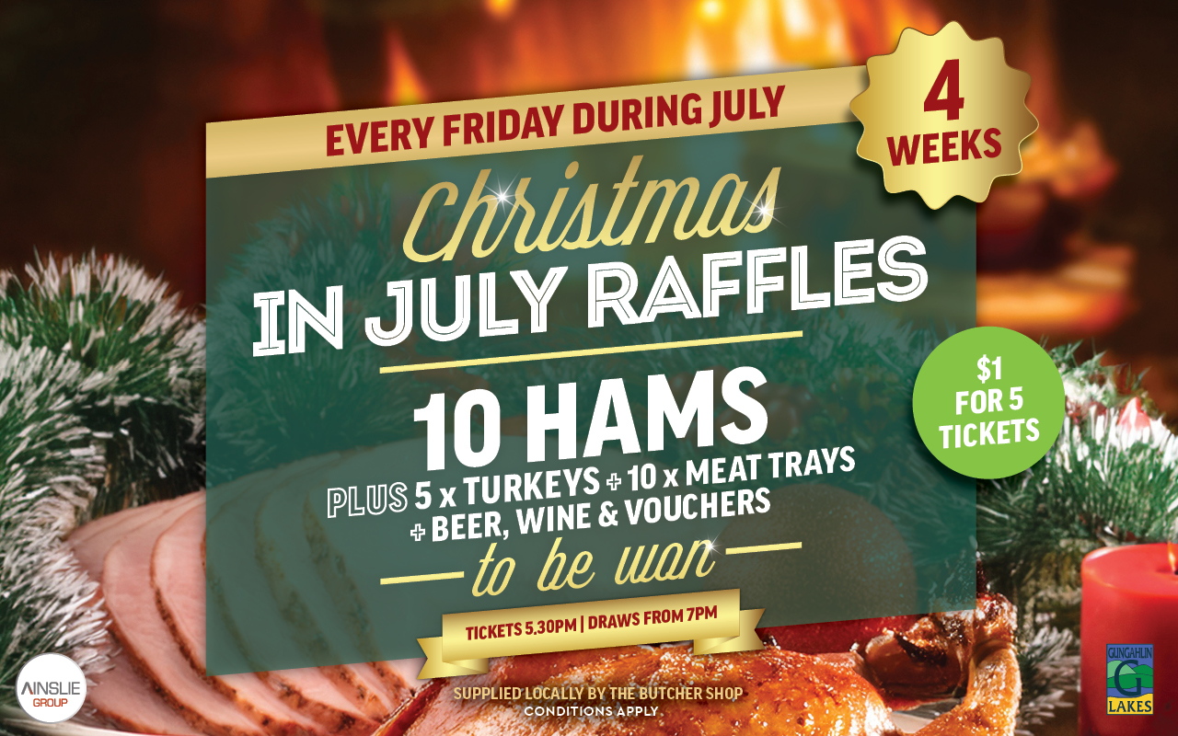

Rules and Regulations:
- This promotion is open to any member or visitor of Ainslie Football & Social Club and Gungahlin Lakes Golf & Community Club.
- Entrants must be 18 years or older to win the prizes as the prizes may contain alcoholic beverages.
- The “Christmas in July Raffles” promotion is not valid in conjunction with any other promotion.
- The promoter of the “Christmas Ham Raffles” promotion is the Ainslie Group Limited. ABN: 17 102 364 321.
- Ainslie Group reserves the right to change the terms and conditions at any time.

